EmbrWave Multi-site study

Researcher and translation instructions

We’ve added comments to major areas that may require changes on a per-site level. Please favor making the materials appropriate for your sample over literal translation or rigidly sticking to this script. Please also review all text in case there are areas we missed.

Text in red are researcher notes only. We’ve labelled each measure for clarity, but this will not be shown to participants. We also indicate in red when the status of the EmbrWave changes.

6 Asterix points indicate a new page: ******

Generally, the EmbrWave will activate to pre-specified levels during the beginning and end of the study (when participants are asked about it). Before each DV, the EmbrWave will be inactive for 5 seconds, then be activated to a random level of heating/cooling until the DV is answered. The EmbrWave will be inactive for the demographics.

Individual differences/demographics section will randomly appear either before or before or after the ‘Main Test Block’ with the DVs.

Consent to be a Research Subject

**Introduction**This research study is being conducted by Dr. XX at XX, in collaboration with Drs. Richard Klein and Hans IJzerman at Université Grenoble Alpes. The goal of this research is to determine the efficacy of a device to adjust temperature (the EmbrWave) and to collect data on various research questionnaires. You were invited to participate because you are a student at XXXX or live in the surrounding area.

**Procedures**If you agree to participate in this research study, the following will occur:

* you will be fitted with a device that heats up and cools down on your wrist [5 minutes]
* you will respond to various questionnaires on the computer concerning your personality, preferences, and various scenarios [50 minutes]
* you will be asked some questions about the EmbrWave [5 minutes]
* entire study will be completed in one lab session
* total time commitment will be about 60 minutes or less.

**Risks/Discomforts   
There is minimal risk to you as a participant. The questions you will be asked are no different than the sorts of questions and situations you may experience in everyday life. We will test the EmbrWave heating/cooling functions prior to beginning the study to ensure it is not uncomfortable for you.**

**Benefits**There will be no direct benefits to you. It is hoped you may enjoy the experience of testing this new consumer product to control personal temperature and the information you provide will be insightful for research into temperature manipulation.

**Confidentiality**The research data will be kept digitally in a secured file storage system and only the current researchers will have access to the raw data. At the conclusion of the study, if all potentially identifying information is able to be removed, we will upload anonymized data to a research website (the Open Science Framework) where other researchers can benefit from these data as well.

**Compensation**You will receive course credit in exchange for your participation.

**Participation**Participation in this research study is voluntary. You have the right to withdraw at any time or refuse to participate entirely without jeopardy to your class status, grade, or standing with the university.

**Questions about the Research**If you have questions regarding this study, you may contact Dr. XX (email) for further information.

**Questions about Your Rights as Research Participants**If you have questions regarding your rights as a research participant contact the IRB Administrator at XX.

**Statement of Consent**I have read, understood, and received a copy of the above consent and desire of my own free will to participate in this study.

Name (Printed): Signature Date:

******

We are testing the efficacy of a new consumer product: the EmbrWave, produced by EmbrLabs. The EmbrWave is a device that you wear that can serve as an individualized heater or cooler. We are working with EmbrLabs to test their product for them. We want to test this for them in a situation intended to mimic everyday life, when you might wear the EmbrWave while doing other things. To make full use of your time, we will ask you to wear this product while you complete some surveys for our psychology department. All instructions will be presented on the computer screen. The device will heat and cool at different intervals, but you don't have to pay much attention to it. At the start and end of the session, we will ask you some questions about what you thought of the EmbrWave, whether you would want to purchase it, and whether you would recommend the product to others.

******

Welcome to the study. Remember that the EmbrWave will heat and cool repeatedly during this study. If you are uncomfortable at any point, please remove the device and find your experimenter. Please begin when you are ready.

******

At the moment, are you too cold, comfortable, or too hot?

1 – too cold

2

3

4 – comfortable

5

6

7 – too hot

******

EmbrWave 10 seconds max heating

Please wait.

******

EmbrWave 10 seconds max cooling

Please wait.

******

EmbrWave idle (neutral temperature)

To confirm whether the EmbrWave was working, did you feel the EmbrWave heat up and cool down during this demonstration? Yes/No

******

If the EmbrWave was not heating and cooling, please find your experimenter so they can troubleshoot the device.

******

The EmbrWave will now continue to heat and cool but we will not ask you anymore questions about it until the end. There may also be long periods where it does not heat or cool – do not be alarmed about this. Please simply respond to the various questions and scenarios we present to you.

******

Note: randomly display either the main testing block, or the individual differences/demographics block first.

MAIN TEST BLOCK BEGINS – Each dv presented to participant in random order

EmbrWave idle (5 seconds)

Please wait.

******

DV1_similarity_objects

EmbrWave initiates random heating/cooling session. Maintains same heating/cooling throughout this DV.

Next, we will present you with some pairs of objects. Please rate how similar or different they seem to you.

whale–dolphin

1 – very different

2

3

4

5

6 – very similar

white wine–red wine

1 – very different

2

3

4

5

6 – very similar

bicycle–motorcycle

1 – very different

2

3

4

5

6 – very similar

peach–nectarine

1 – very different

2

3

4

5

6 – very similar

broccoli–zucchini

1 – very different

2

3

4

5

6 – very similar

pen–pencil

1 – very different

2

3

4

5

6 – very similar

******

EmbrWave idle (5 seconds)

Please wait.

******

DV2_belonging

EmbrWave initiates random heating/cooling session. Maintains same heating/cooling throughout this DV.

In this section we will ask several questions about how you are feeling. For each question, please select the number that best represents your current feelings.

1. I feel “disconnected”

1 - not at all

2

3

4

5 - extremely

2. I feel rejected

1 - not at all

2

3

4

5 - extremely

3. I feel like an outsider

1 - not at all

2

3

4

5 - extremely

4. I feel I belong

1 - not at all

2

3

4

5 - extremely

5. I feel other people interact with me a lot

1 - not at all

2

3

4

5 - extremely

******

EmbrWave idle (5 seconds)

Please wait.

******

DV3_utilitarian

EmbrWave initiates random heating/cooling session. Maintains same heating/cooling throughout this DV.

In this next section, we will ask you to read several scenarios and indicate your opinion about them.

******

Enemy soldiers have taken over your village. They have orders to kill all remaining civilians. You and some of your townspeople have sought refuge in the cellar of a large house. Outside you hear the voices of soldiers who have come to search the house for valuables.

Your baby begins to cry loudly. You cover his mouth to block the sound. If you remove your hand from his mouth his crying will summon the attention of the soldiers who will kill you, your child, and the others hiding out in the cellar. To save yourself and the others you must smother your child to death.

Is it appropriate for you to smother your child in order to save yourself and the other townspeople?

1 = completely inappropriate, 7 = completely appropriate

******

A runaway trolley is heading down the tracks toward five workmen who will be killed if the trolley proceeds on its present course. You are on a footbridge over the tracks, in between the approaching trolley and the five workmen. Next to you on this footbridge is a stranger who happens to be very large.

The only way to save the lives of the five workmen is to push this stranger off the bridge and onto the tracks below where his large body will stop the trolley. The stranger will die if you do this, but the five workmen will be saved.

Is it appropriate for you to push the stranger on to the tracks in order to save the five workmen?

1 = completely inappropriate, 7 = completely appropriate

******

It is wartime and you and your two children, ages eight and five, are living in a territory that has been occupied by the enemy. At the enemy's headquarters is a doctor who performs painful experiments on humans that inevitably lead to death.

He intends to perform experiments on one of your children, but he will allow you to choose which of your children will be experimented upon. You have twenty-four hours to bring one of your children to his laboratory. If you refuse to bring one of your children to his laboratory he will find them both and experiment on both of them.

Is it appropriate for you to bring one of your children to the laboratory in order to avoid having them both die?

1 = completely inappropriate, 7 = completely appropriate

******

You are the leader of a mountaineering expedition that is stranded in the wilderness. Your expedition includes a family of six that has a genetically caused vitamin deficiency. A few people's kidneys contain large amounts of this vitamin.

There is one such person in your party. The only way to save the lives of the six members of this family is to remove one of this man's kidneys so that the necessary vitamins may be extracted from it. The man will not die if you do this, but his health will be compromised. The man is opposed to this plan, but you have the power to do as you see fit.

Is it appropriate for you to forcibly remove this man's kidney in order to save the lives of the six vitamin-deficient people?

1 = completely inappropriate, 7 = completely appropriate

******

You are the leader of a small army that consists of warriors from two tribes, the hill tribe and the river tribe. You belong to neither tribe. During the night a hill tribesman got into an argument with a river tribesman and murdered him. The river tribe will attack the hill tribe unless the murderer is put to death, but the hill tribe refuses to kill one of its own warriors.

The only way for you to avoid a war between the two tribes that will costs hundreds of lives is to publicly execute the murderer by cutting off is head with your sword.

Is it appropriate for you to cut off this man's head in order to prevent the two tribes from fighting a war that will cost hundreds of lives?

1 = completely inappropriate, 7 = completely appropriate

******

You are negotiating with a powerful and determined terrorist who is about to set off a bomb in a crowded area. Your one advantage is that you have his teen-age son in your custody.

There is only one thing that you can do to stop him from detonating his bomb, which will kill thousands of people if detonated. To stop him, you must contact him over the satellite hook-up that he has established and, in front of the camera, break one of his son's arms and then threaten to break the other one if he does not give himself up.

Is it appropriate for you to break the terrorist's son's arm in order to prevent the terrorist from killing thousands of people with his bomb?

1 = completely inappropriate, 7 = completely appropriate

******

You are the captain of a military submarine travelling underneath a large iceberg. An onboard explosion has caused you to lose most of your oxygen supply and has injured one of your crew who is quickly losing blood. The injured crew member is going to die from his wounds no matter what happens.

The remaining oxygen is not sufficient for the entire crew to make it to the surface. The only way to save the other crew members is to shoot dead the injured crew member so that there will be just enough oxygen for the rest of the crew to survive.

Is it appropriate for you to kill the fatally injured crew member in order to save the lives of the remaining crew members?

1 = completely inappropriate, 7 = completely appropriate

******

You are a doctor. One of your patients, whom you diagnosed as HIV positive, is about to be released from the hospital. He has told you, in the confidence of your doctor-patient relationship, that he intends to infect as many people as possible with HIV starting that evening.

Because you are bound by doctor-patient confidentiality, there is no legal way to stop this man from carrying out his plan. It occurs to you that you could contaminate his medication with an untraceable poison that will kill him before he gets a chance to infect others.

Is it appropriate for you to poison this man in order to prevent him from spreading HIV?

1 = completely inappropriate, 7 = completely appropriate

******

EmbrWave idle (5 seconds)

Please wait.

******

DV4_nostalgia

EmbrWave initiates random heating/cooling session. Maintains same heating/cooling throughout this DV.

Using the following scale, select a number to indicate what you miss right now about when you were younger and how much you miss it: 1 = not at all, 7 = very much.

Family

1 2 3 4 5 6 7

Heroes or heroines

1 2 3 4 5 6 7

Not having to worry

1 2 3 4 5 6 7

Places

1 2 3 4 5 6 7

Music

1 2 3 4 5 6 7

Someone you loved

1 2 3 4 5 6 7

Friends

1 2 3 4 5 6 7

Things you did

1 2 3 4 5 6 7

Toys

1 2 3 4 5 6 7

The way people were

1 2 3 4 5 6 7

Feelings you had

1 2 3 4 5 6 7

TV shows, movies

1 2 3 4 5 6 7

School

1 2 3 4 5 6 7

Having someone to depend on

1 2 3 4 5 6 7

Holidays

1 2 3 4 5 6 7

The way society was

1 2 3 4 5 6 7

Pet or pets

1 2 3 4 5 6 7

Not knowing sad or evil things

1 2 3 4 5 6 7

Church or temple, etc.

1 2 3 4 5 6 7

Your house

1 2 3 4 5 6 7

******

EmbrWave idle (5 seconds)

Please wait.

******

DV5_houses_homelikeness

EmbrWave initiates random heating/cooling session. Maintains same heating/cooling throughout this DV.

Next, we are going to present you with a house. After reading the information and examining the photos, we’ll ask you what you think about the house.

******

What do you think about this house?

General Information

The resale value of the house is $225,000. It has six bedrooms, it’s located close to several parks, schools, and public transportation. The property has a large master bedroom, kitchen, and backyard.

Layout

Ground floor:

Hallway, toilet and sink, and stairs to the first floor. Living room at the front of the house, dining area and open kitchen located at the rear of the house.

Second floor:

Hallway offering access to four bedrooms and a bathroom. Two bedrooms are located on the front of the house, and two bedrooms are located on the back.

Third floor:

Here is the 5th bedroom.

Photos

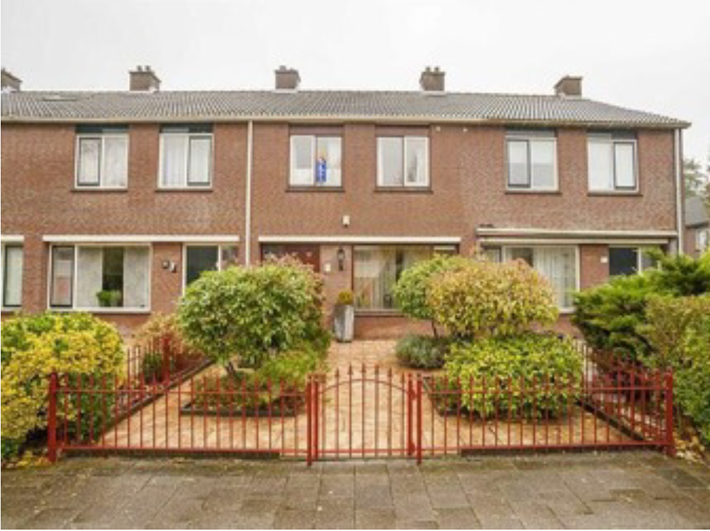

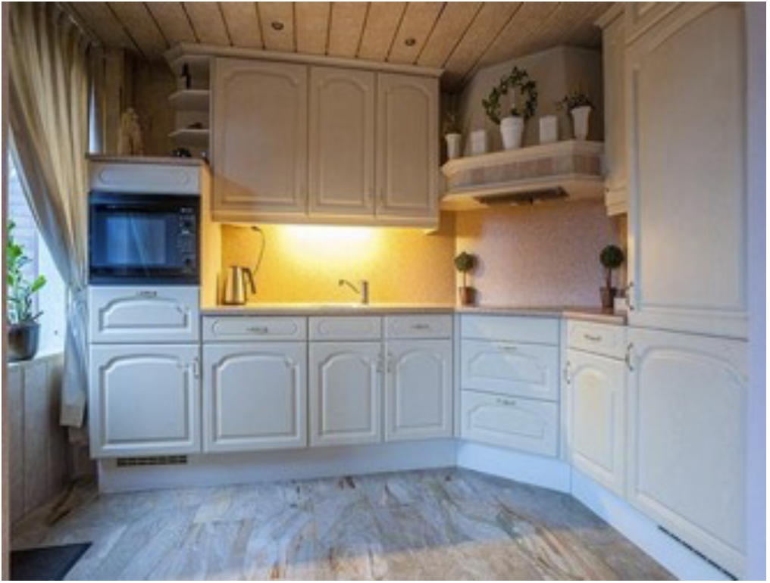

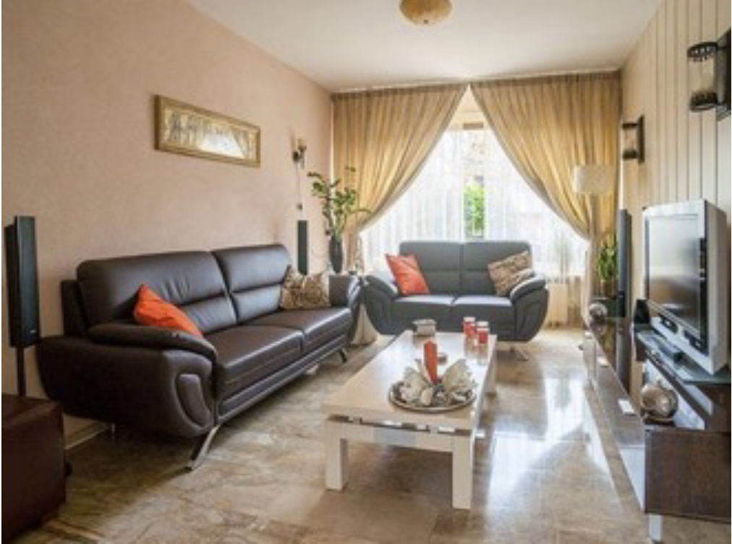

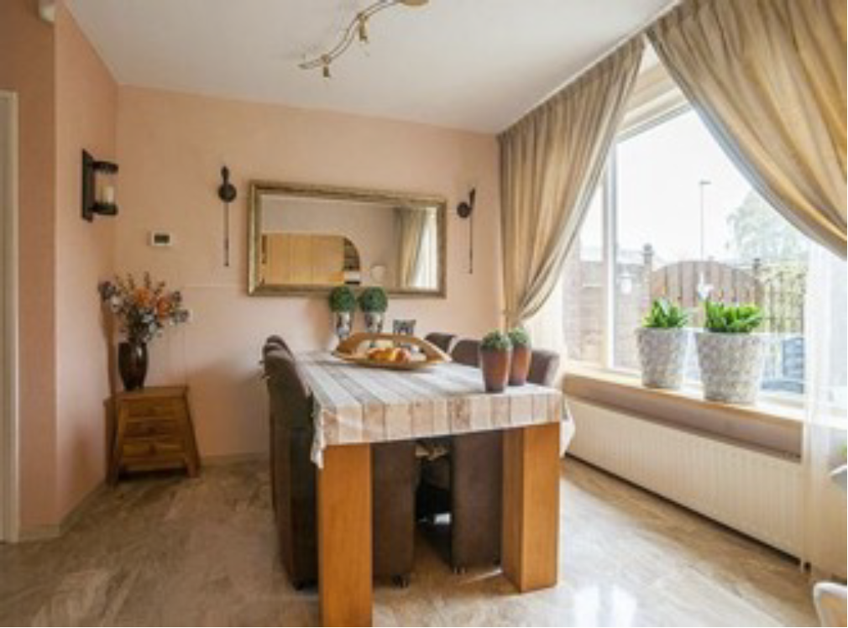

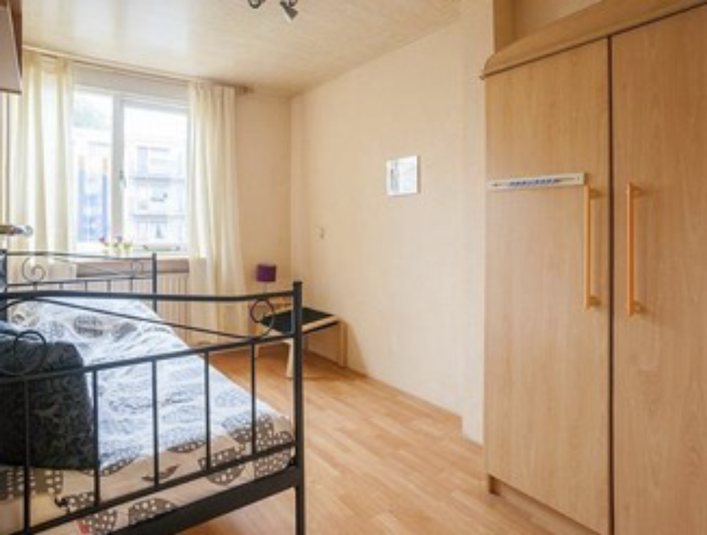

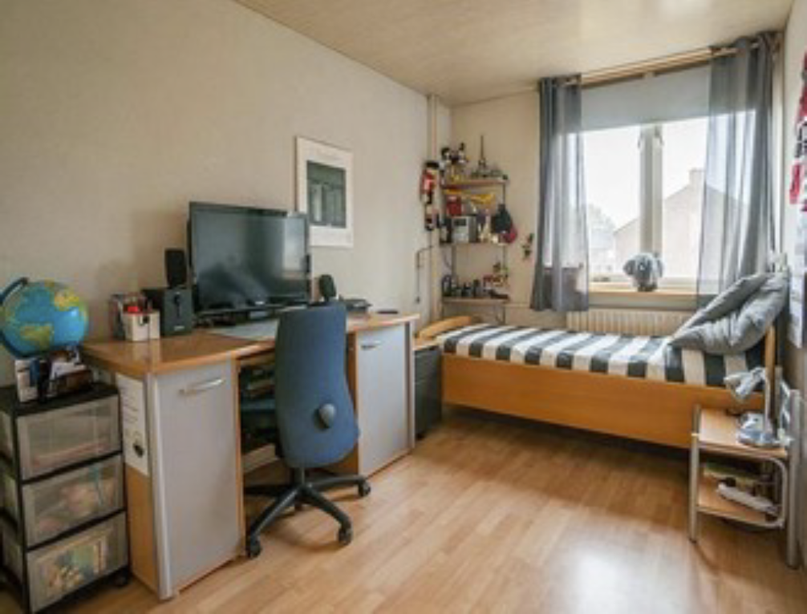

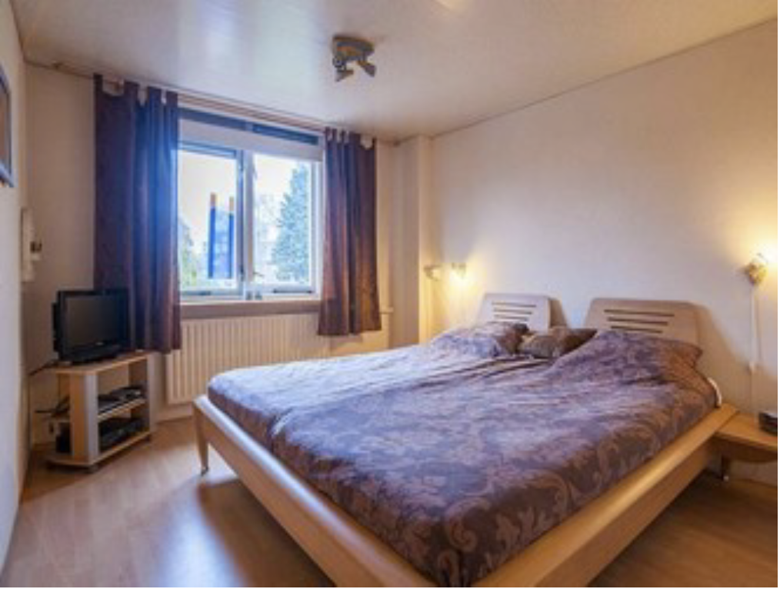

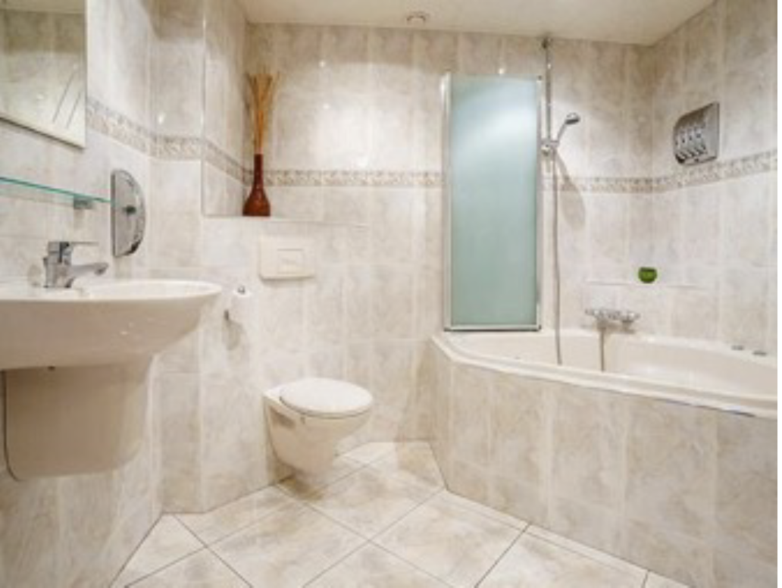

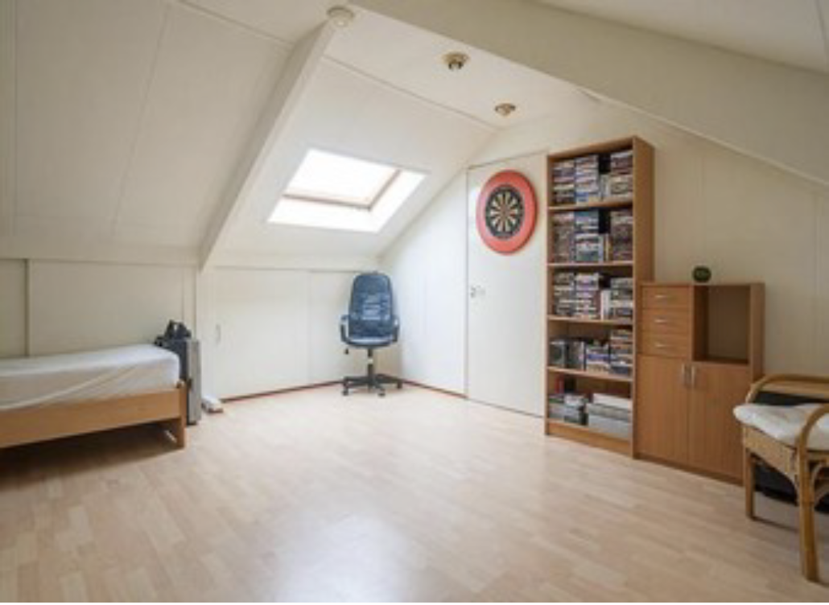

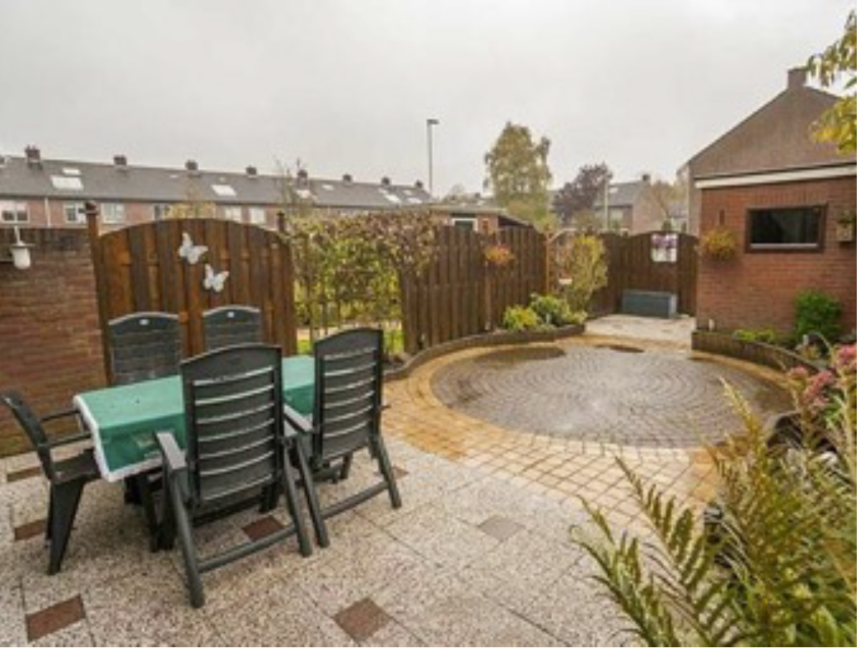

Now, we will ask you to rate how you feel about the house on several different dimensions. The scale is always the same: 1 = not at all, 7 = to a great extent

To what extent does the property seem (or feel) …

1. Safe

not at all – 1 2 3 4 5 6 7 – to a great extent

1. Familiar

not at all – 1 2 3 4 5 6 7 – to a great extent

1. Warm

not at all – 1 2 3 4 5 6 7 – to a great extent

1. Like a ‘home’

not at all – 1 2 3 4 5 6 7 – to a great extent

1. Soothing

not at all – 1 2 3 4 5 6 7 – to a great extent

1. Relaxing

not at all – 1 2 3 4 5 6 7 – to a great extent

1. Comfortable

not at all – 1 2 3 4 5 6 7 – to a great extent

1. Private

not at all – 1 2 3 4 5 6 7 – to a great extent

1. Like a quality house

not at all – 1 2 3 4 5 6 7 – to a great extent

******

EmbrWave idle (5 seconds)

Please wait.

******

DV6_criminal_rating

EmbrWave initiates random heating/cooling session. Maintains same heating/cooling throughout this DV.

In this section we will show you pictures of people who committed crimes (‘mugshots’) from an online database. Each of these individuals committed a crime, but we will ask you about the type of crime you think each one committed.

******

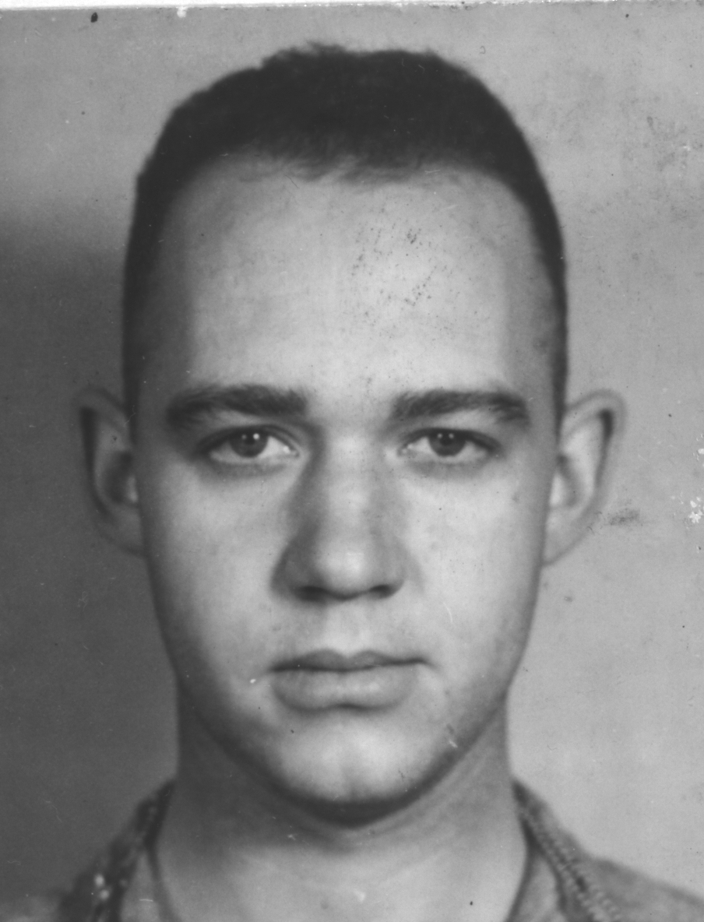

1. How likely is it that this person committed a **premeditated crime**?

very unlikely – 1 2 3 4 5 6 7 – very likely

2. How likely is it that this person committed an **impulsive crime**?

very unlikely – 1 2 3 4 5 6 7 – very likely

******

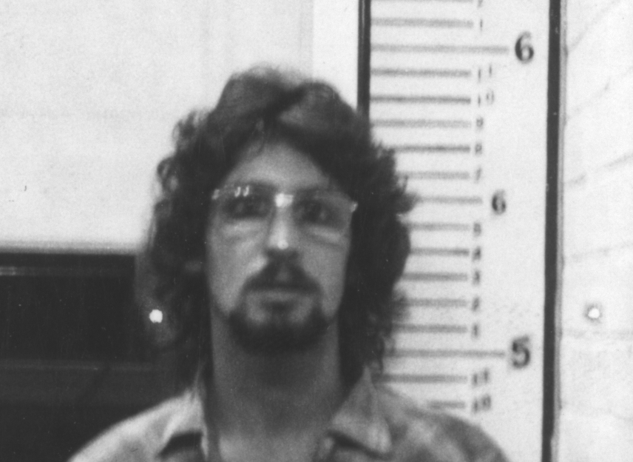

1. How likely is it that this person committed a **premeditated crime**?

very unlikely – 1 2 3 4 5 6 7 – very likely

2. How likely is it that this person committed an **impulsive crime**?

very unlikely – 1 2 3 4 5 6 7 – very likely

******

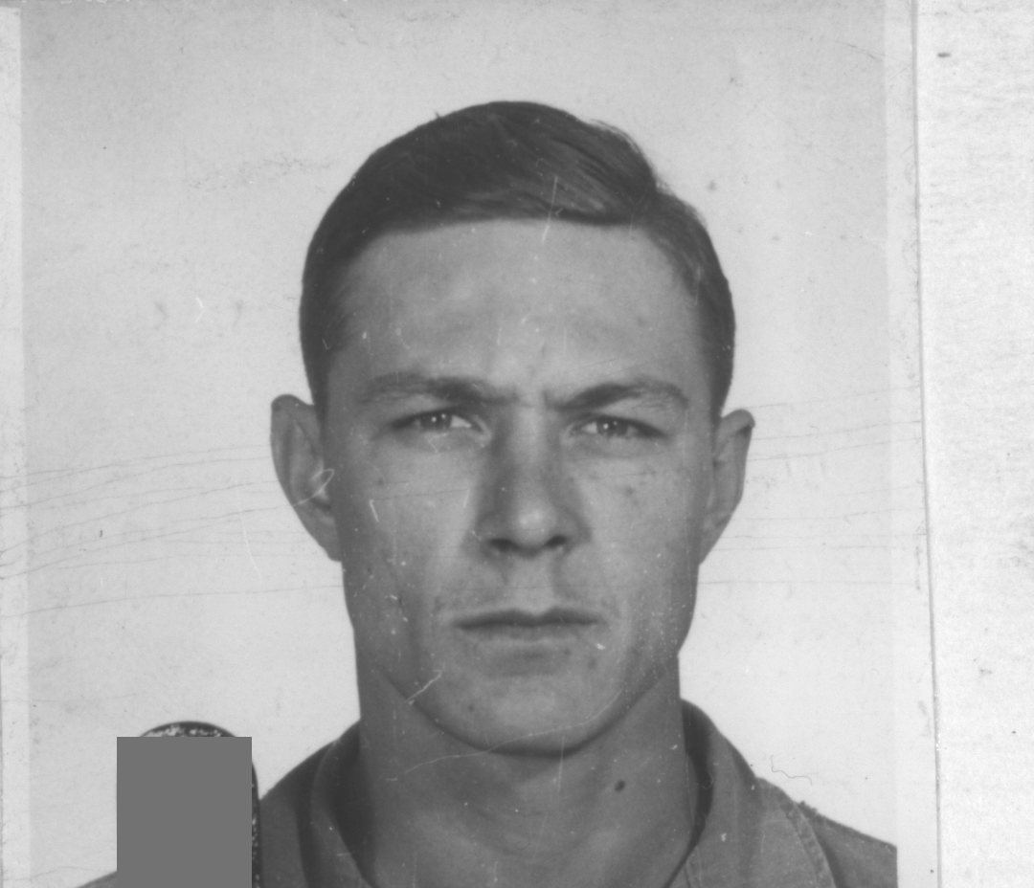

1. How likely is it that this person committed a **premeditated crime**?

very unlikely – 1 2 3 4 5 6 7 – very likely

2. How likely is it that this person committed an **impulsive crime**?

very unlikely – 1 2 3 4 5 6 7 – very likely

******

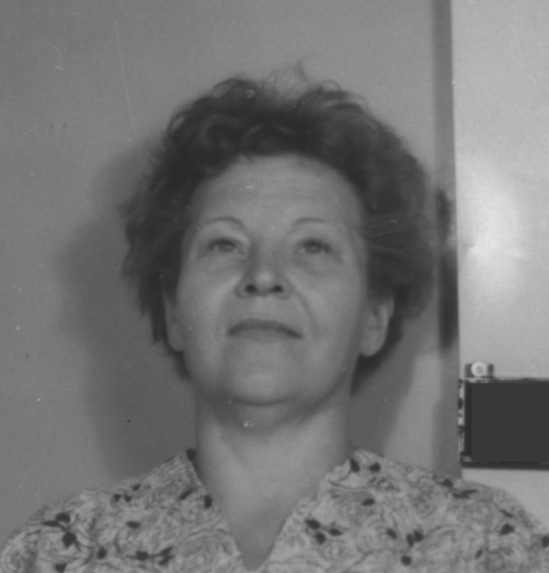

1. How likely is it that this person committed a **premeditated crime**?

very unlikely – 1 2 3 4 5 6 7 – very likely

2. How likely is it that this person committed an **impulsive crime**?

very unlikely – 1 2 3 4 5 6 7 – very likely

******

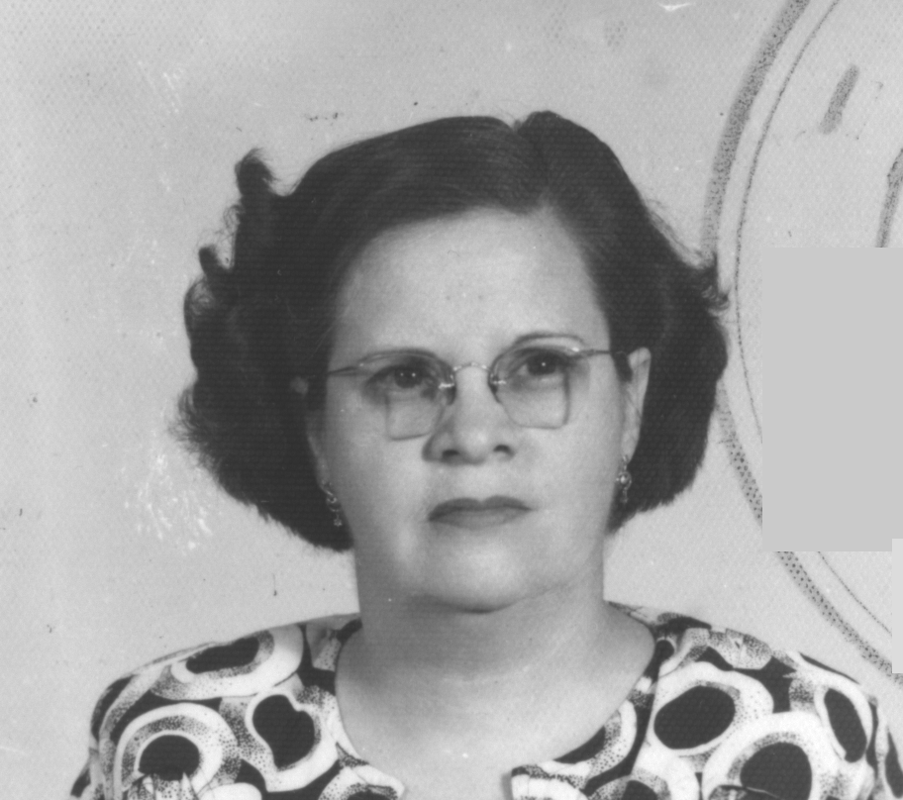

1. How likely is it that this person committed a **premeditated crime**?

very unlikely – 1 2 3 4 5 6 7 – very likely

2. How likely is it that this person committed an **impulsive crime**?

very unlikely – 1 2 3 4 5 6 7 – very likely

******

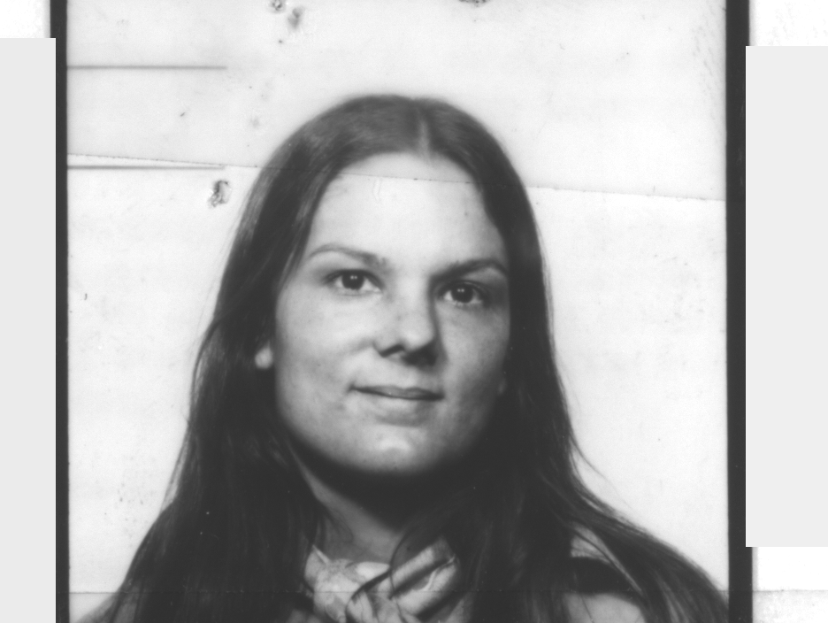

1. How likely is it that this person committed a **premeditated crime**?

very unlikely – 1 2 3 4 5 6 7 – very likely

2. How likely is it that this person committed an **impulsive crime**?

very unlikely – 1 2 3 4 5 6 7 – very likely

******

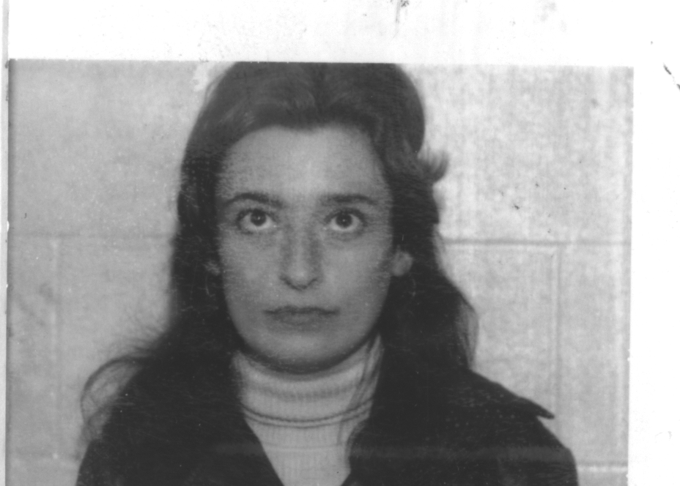

1. How likely is it that this person committed a **premeditated crime**?

very unlikely – 1 2 3 4 5 6 7 – very likely

2. How likely is it that this person committed an **impulsive crime**?

very unlikely – 1 2 3 4 5 6 7 – very likely

******

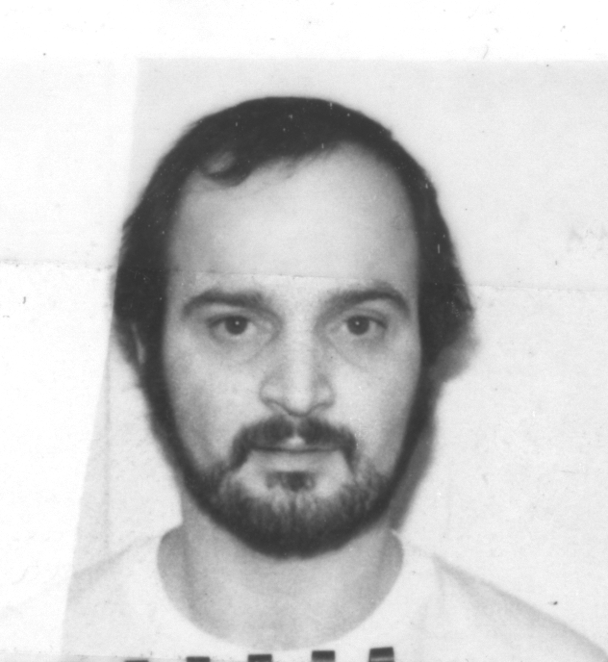

1. How likely is it that this person committed a **premeditated crime**?

very unlikely – 1 2 3 4 5 6 7 – very likely

2. How likely is it that this person committed an **impulsive crime**?

very unlikely – 1 2 3 4 5 6 7 – very likely

******

EmbrWave idle (5 seconds)

Please wait.

******

DV7_perceptualfocus

EmbrWave initiates random heating/cooling session. Maintains same heating/cooling throughout this DV.

In this next section, you will be asked to assess 6 figures. A 'target object' will be shown at the top of the screen, with two other objects below it. The goal is for you to judge which of the two objects looks like the one at the top. Do not think too long, instead use your first instinct. There is no right or wrong!

First, we will give you a sample question so you know what it looks like.

******

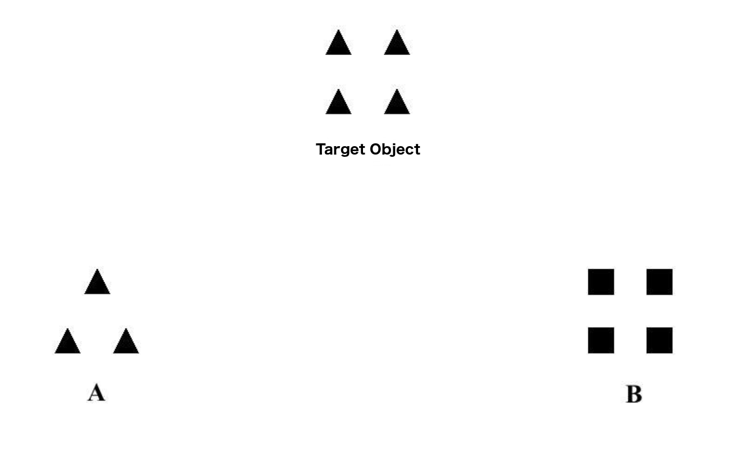

Sample question: Which object most resembles the target object to you? [Object A/Object B]

******

“That was the sample question. You will get 6 more figures to evaluate. The question remains the same: Which object (A or B) most resembles the target object to you? Good luck!

******

******

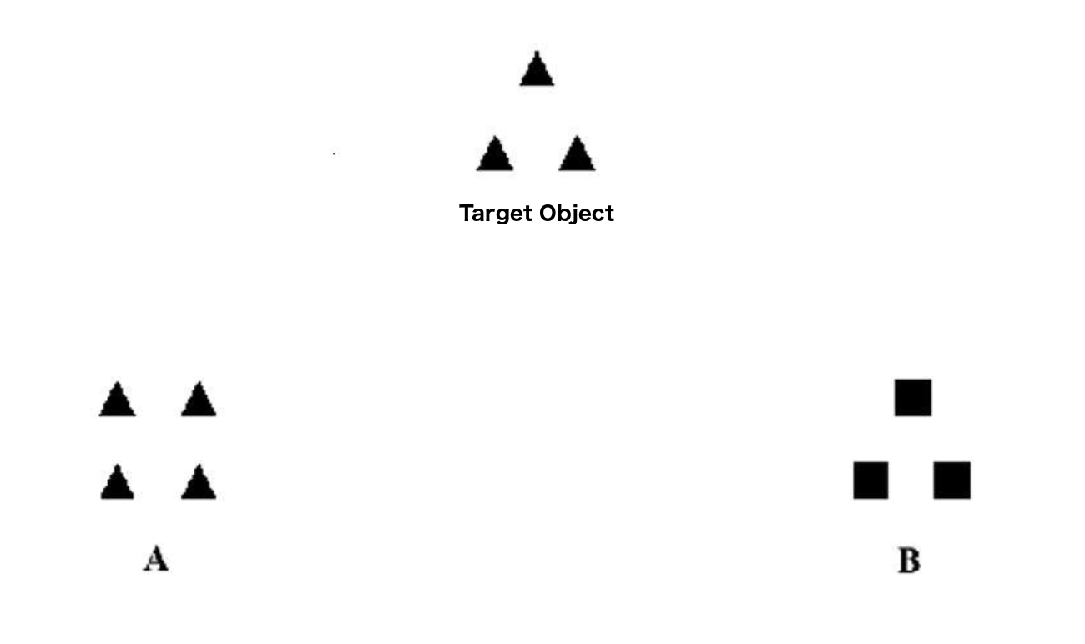

Which object most resembles the target object to you? [Object A/Object B]

******

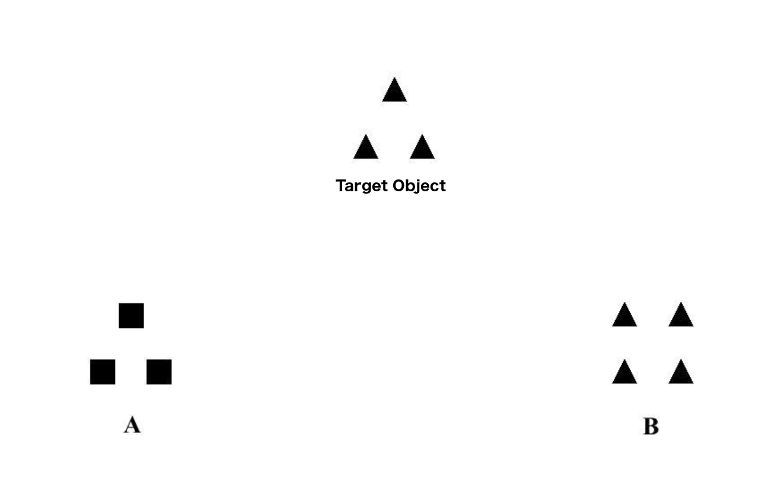

Which object most resembles the target object to you? [Object A/Object B]

******

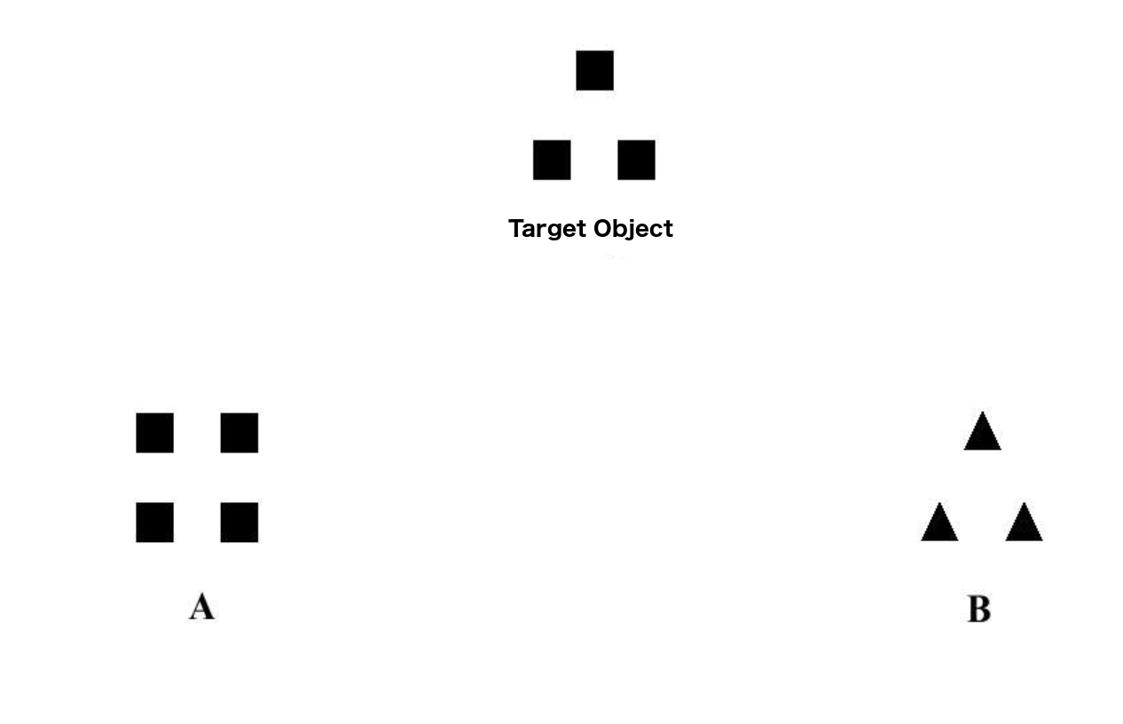

Which object most resembles the target object to you? [Object A/Object B]

******

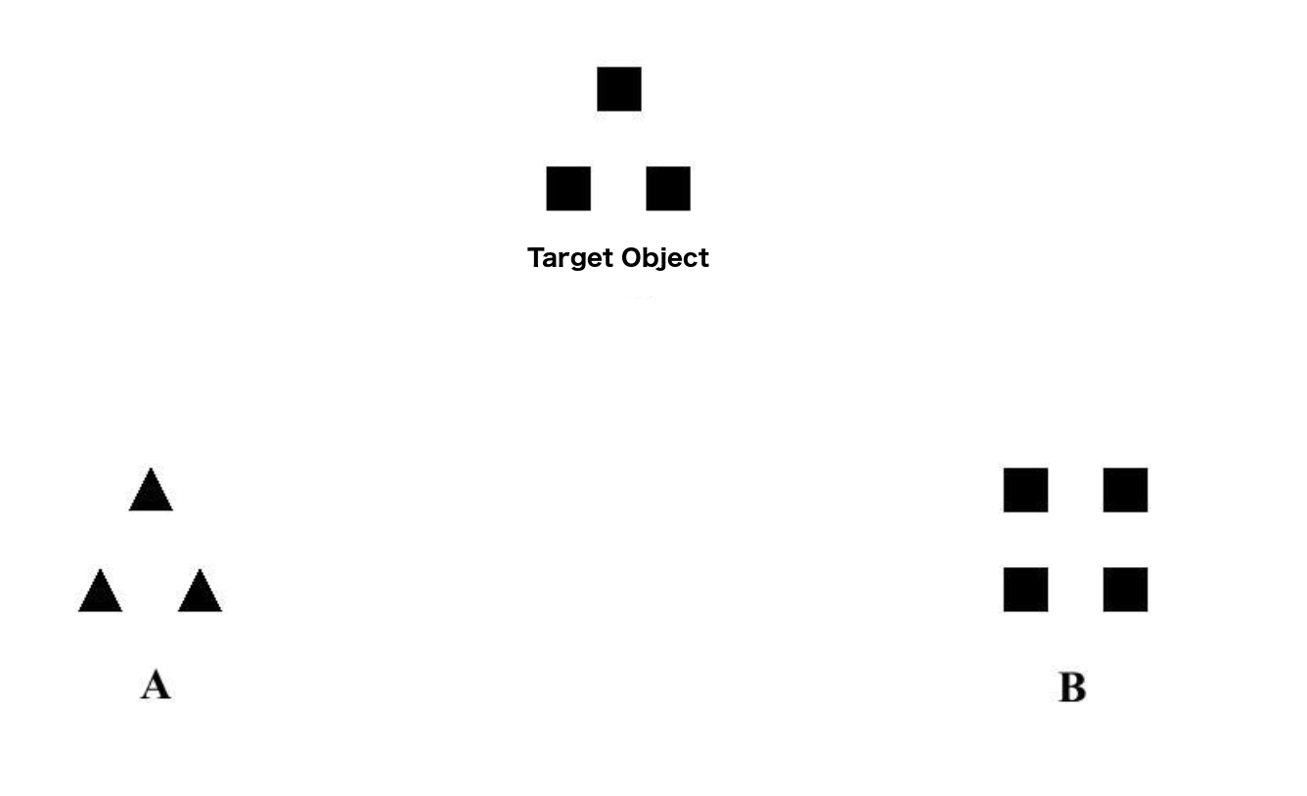

Which object most resembles the target object to you? [Object A/Object B]

******

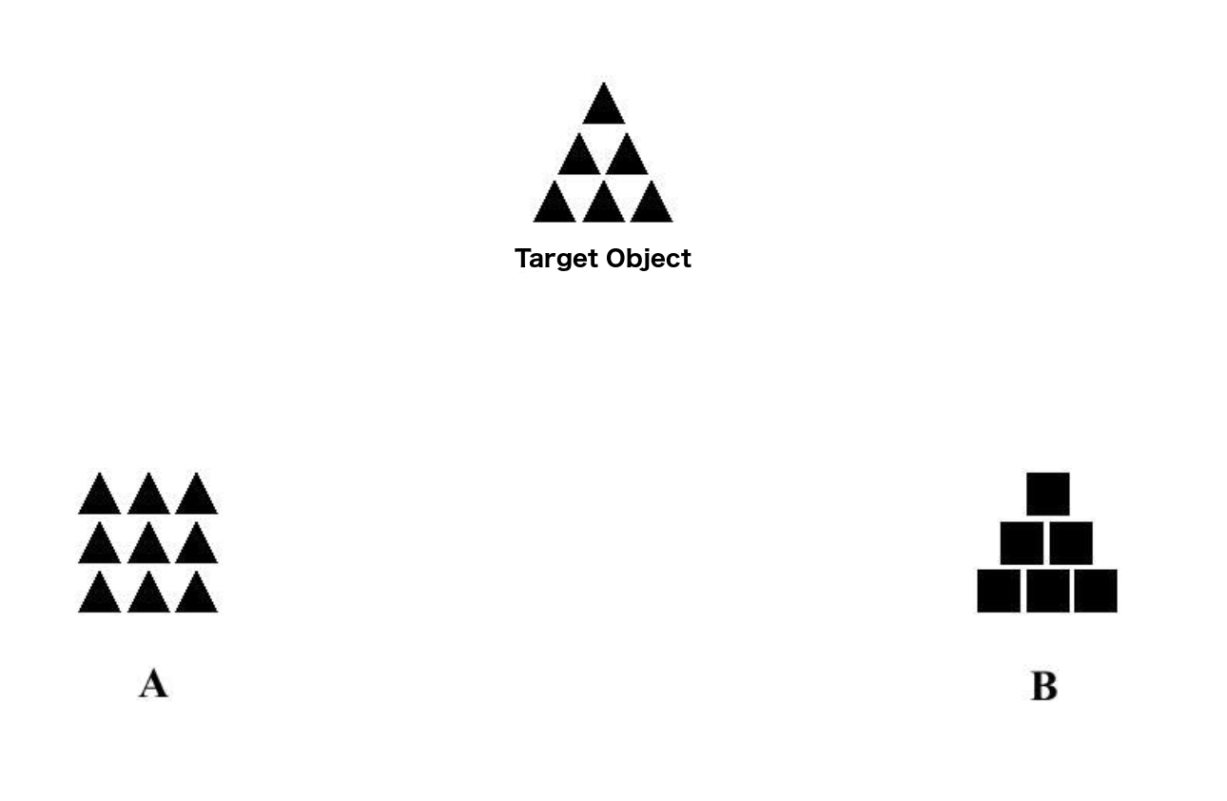

Which object most resembles the target object to you? [Object A/Object B]

******

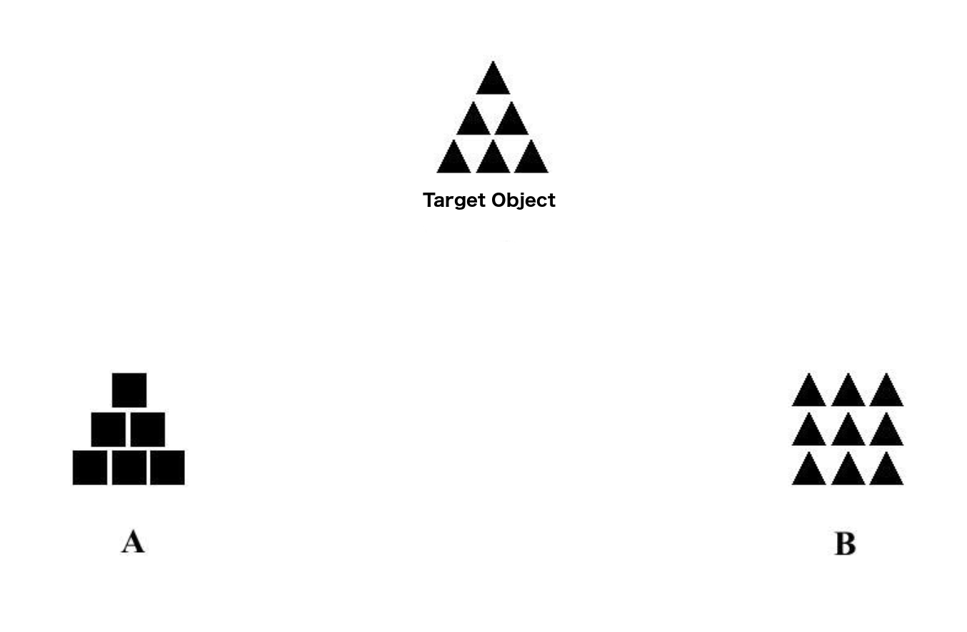

Which object most resembles the target object to you? [Object A/Object B]

******

EmbrWave idle (5 seconds)

Please wait.

******

DV8_brand_personality

EmbrWave initiates random heating/cooling session. Maintains same heating/cooling throughout this DV.

******

In this next section, we will ask for your impressions of three major shoe brands. If you are not familiar with the shoe brand, simply skip the questions about that brand.

******

Please answer the following questions about ADIDAS.

How “warm” do you consider this brand?

Not at all “warm” – 1 2 3 4 5 6 7 – very “warm”

How friendly do you consider this brand?

Not at all friendly – 1 2 3 4 5 6 7 – very friendly

This brand has good intentions toward ordinary people.

Totally disagree – 1 2 3 4 5 6 7 – totally agree

This brand consistently acts with the public’s best interest in mind.

Totally disagree – 1 2 3 4 5 6 7 – totally agree

This brand is rugged

Totally disagree – 1 2 3 4 5 6 7 – totally agree

This brand represents competence

Totally disagree – 1 2 3 4 5 6 7 – totally agree

This brand is aggressive

Totally disagree – 1 2 3 4 5 6 7 – totally agree

******

Please answer the following questions about NIKE.

How “warm” do you consider this brand?

Not at all “warm” – 1 2 3 4 5 6 7 – very “warm”

How friendly do you consider this brand?

Not at all friendly – 1 2 3 4 5 6 7 – very friendly

This brand has good intentions toward ordinary people.

Totally disagree – 1 2 3 4 5 6 7 – totally agree

This brand consistently acts with the public’s best interest in mind.

Totally disagree – 1 2 3 4 5 6 7 – totally agree

This brand is rugged

Totally disagree – 1 2 3 4 5 6 7 – totally agree

This brand represents competence

Totally disagree – 1 2 3 4 5 6 7 – totally agree

This brand is aggressive

Totally disagree – 1 2 3 4 5 6 7 – totally agree

******

Please answer the following questions about REEBOK.

How “warm” do you consider this brand?

Not at all “warm” – 1 2 3 4 5 6 7 – very “warm”

How friendly do you consider this brand?

Not at all friendly – 1 2 3 4 5 6 7 – very friendly

This brand has good intentions toward ordinary people.

Totally disagree – 1 2 3 4 5 6 7 – totally agree

This brand consistently acts with the public’s best interest in mind.

Totally disagree – 1 2 3 4 5 6 7 – totally agree

This brand is rugged

Totally disagree – 1 2 3 4 5 6 7 – totally agree

This brand represents competence

Totally disagree – 1 2 3 4 5 6 7 – totally agree

This brand is aggressive

Totally disagree – 1 2 3 4 5 6 7 – totally agree

******

EmbrWave idle (5 seconds)

Please wait.

******

DV9_loneliness

EmbrWave initiates random heating/cooling session. Maintains same heating/cooling throughout this DV.

******

**Instructions**: The following statements describe how people sometimes feel. For each statement, please indicate how often you feel the way described by selecting one of the responses below. Here is an example:

How often do you feel happy?

If you never felt happy, you would respond “never”; if you always feel happy, you would respond “always.”

1. How often do you feel that you are “in tune” with the people around you?

1. Never
2. Rarely
3. Sometimes
4. Always

2. How often do you feel that you lack companionship?

1. Never
2. Rarely
3. Sometimes
4. Always

3. How often do you feel that there is no one you can turn to?

1. Never
2. Rarely
3. Sometimes
4. Always

4. How often do you feel alone?

1. Never
2. Rarely
3. Sometimes
4. Always

5. How often do you feel part of a group of friends?

1. Never
2. Rarely
3. Sometimes
4. Always

6. How often do you feel that you have a lot in common with the people around you?

1. Never
2. Rarely
3. Sometimes
4. Always

7. How often do you feel that you are no longer close to anyone?

1. Never
2. Rarely
3. Sometimes
4. Always

8. How often do you feel that your interests and ideas are not shared by those around you?

1. Never
2. Rarely
3. Sometimes
4. Always

9. How often do you feel outgoing and friendly?

1. Never
2. Rarely
3. Sometimes
4. Always

10. How often do you feel close to people?

1. Never
2. Rarely
3. Sometimes
4. Always

11. How often do you feel left out?

1. Never
2. Rarely
3. Sometimes
4. Always

12. How often do you feel that your relationships with others are not meaningful?

1. Never
2. Rarely
3. Sometimes
4. Always

13. How often do you feel that no one really knows you well?

1. Never
2. Rarely
3. Sometimes
4. Always

14. How often do you feel isolated from others?

1. Never
2. Rarely
3. Sometimes
4. Always

15. How often do you feel that you can find companionship when you want it?

1. Never
2. Rarely
3. Sometimes
4. Always

16. How often do you feel that there are people who really understand you?

1. Never
2. Rarely
3. Sometimes
4. Always

17. How often do you feel shy?

1. Never
2. Rarely
3. Sometimes
4. Always

18. How often do you feel that people are around you but not with you?

1. Never
2. Rarely
3. Sometimes
4. Always

19. How often do you feel that there are people you can talk to?

1. Never
2. Rarely
3. Sometimes
4. Always

20. How often do you feel that there are people you can turn to?

1. Never
2. Rarely
3. Sometimes
4. Always

******

EmbrWave idle (5 seconds)

Please wait.

******

DV10_willingnesstoforgive

EmbrWave initiates random heating/cooling session. Maintains same heating/cooling throughout this DV.

******

You and your classmate A attended a course that required a term paper. Upon A’s request, you gave your paper to A for reference. However, the professor later told you that your paper was identical to A’s and asked you to rewrite it or you would receive no credit for the course.

How willing would you be to forgive your classmate?

Certainly not – 1 2 3 4 5 6 7 8 9 10 – Certainly

******

EmbrWave idle (5 seconds)

Please wait.

******

DV11_thinkingaboutlovedones

EmbrWave initiates random heating/cooling session. NOTE: Maintains heating/cooling only until indicated – only for part of this DV.

Please think of someone who you know. Write the name of the first person to come to mind:

_______________________ [name 1]

******

Please think of someone else who you know, but do not repeat someone’s name you used previously in this exercise. Write the name of the first person to come to mind:

_______________________[name 2]

******

Please think of someone else who you know, but do not repeat someone’s name you used previously in this exercise. Write the name of the first person to come to mind:

_______________________[name 3]

******

Please think of someone else who you know, but do not repeat someone’s name you used previously in this exercise. Write the name of the first person to come to mind:

_______________________[name 4]

******

Please think of someone else who you know, but do not repeat someone’s name you used previously in this exercise. Write the name of the first person to come to mind:

_______________________[name 5]

******

EmbrWave idle (5 seconds)

Please wait.

******

Which picture best describes your relationship with [name 1]?

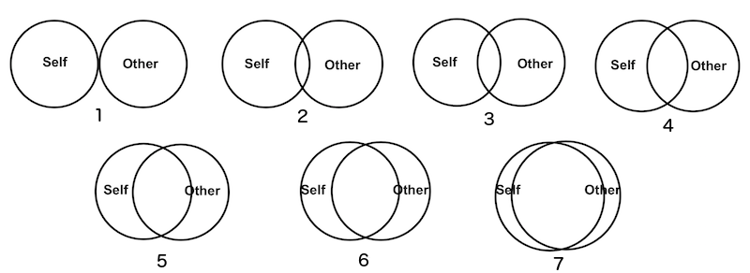

******

Which picture best describes your relationship with [name 2]?



******

Which picture best describes your relationship with [name 3]?



******

Which picture best describes your relationship with [name 4]?



******

Which picture best describes your relationship with [name 5]?



******

EmbrWave idle (5 seconds)

Please wait.

******

DV12_rating_personalities

EmbrWave initiates random heating/cooling session. Maintains same heating/cooling throughout this DV.

******

Consider the following person: Person X is intelligent, skillful, and industrious. Person X is also determined, practical, and cautious.

How would you rate this person on the following traits?

Ungenerous – 1 2 3 4 5 6 7 – Generous

Unhappy – 1 2 3 4 5 6 7 – Happy

Irritable – 1 2 3 4 5 6 7 – Good-natured

Anti-social – 1 2 3 4 5 6 7 – Sociable

Selfish – 1 2 3 4 5 6 7 – Caring

Unattractive – 1 2 3 4 5 6 7 – Attractive

Serious – 1 2 3 4 5 6 7 – Carefree

Quiet – 1 2 3 4 5 6 7 – Talkative

Weak – 1 2 3 4 5 6 7 – Strong

Dishonest – 1 2 3 4 5 6 7 – Honest

******

EmbrWave idle (5 seconds)

Please wait.

******

DV13_willingness_to_pay

EmbrWave initiates random heating/cooling session. Maintains same heating/cooling throughout this DV.

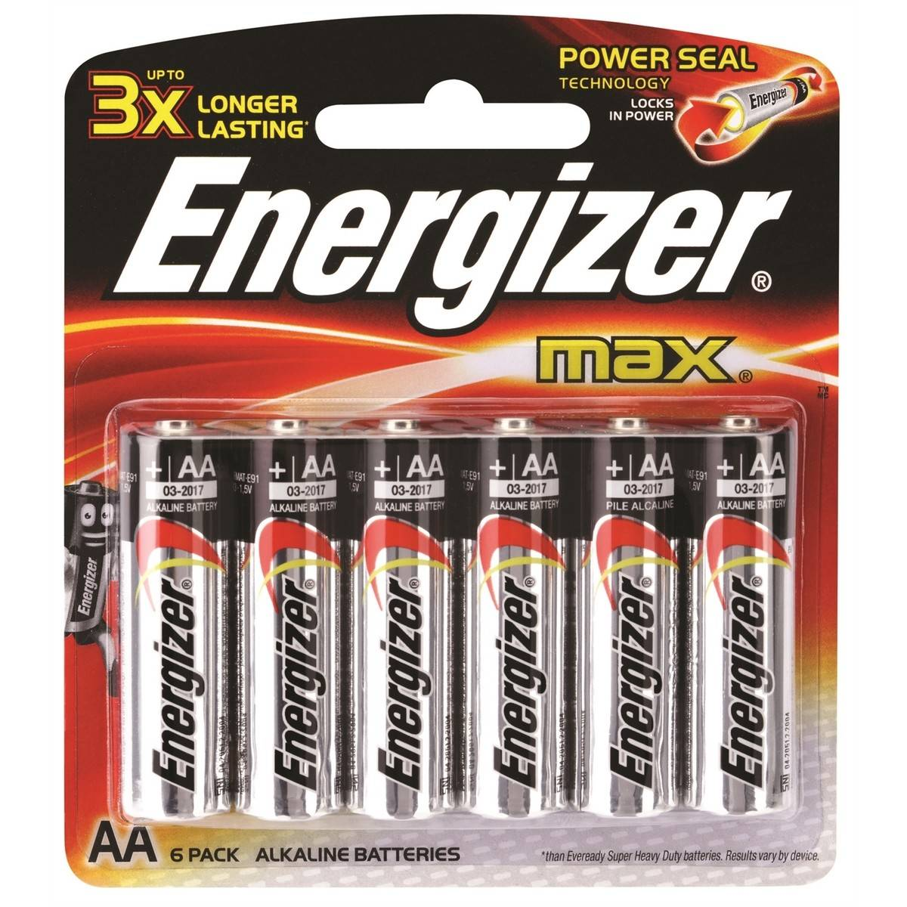

How much would you be willing to pay for this pack of batteries? (please enter only a number) ___

How much do you think this pack of batteries retails for? (please enter only a number) ___

******

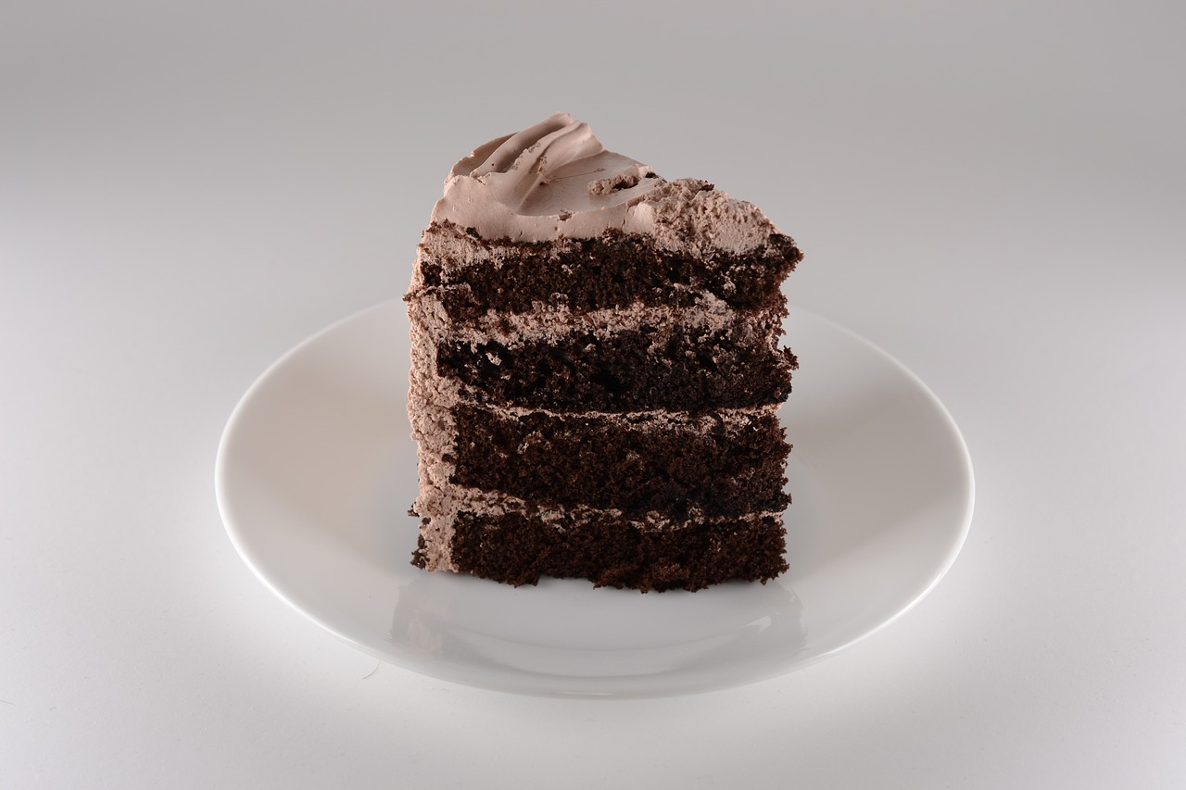

How much would you be willing to pay for this piece of cake? (please enter only a number) ___

How much do you think this piece of cake retails for? (please enter only a number) ___

******

EmbrWave idle (5 seconds)

Please wait.

******

DV14_romance_movies

EmbrWave initiates random heating/cooling session. Maintains same heating/cooling throughout this DV.

******

In this next section, we will show you some information about movies and ask what you think about them. You will do this for 6 movies.

******

Title: Don

Genre: Action

Viewer rating: 7.8/10

Synopsis: Don, a wanted criminal, dies in a police chase. Detective D'Silva is the only one who knows about his death, and to investigate the gang he trains a Don-lookalike named Vijay. But Vijay faces danger from both the police and from within the gang.

How much would you like to watch this movie?

Not at all – 1 2 3 4 5 6 7 – Very much

How good do you think this movie would be?

Not at all – 1 2 3 4 5 6 7 – Very much

Have you seen or heard of this movie before? [Yes – I have seen it/Yes – I have heard of it/No – I didn’t know anything about this movie]

******

Title: The Tough Ones

Genre: Action

Viewer rating: 7.0/10

Synopsis: A tough, rule-bending cop pursues a maniacal, trigger-happy hunchback, a one-handed bank robber and their cronies in an effort to bring Rome's most powerful crime lord to justice.

How much would you like to watch this movie?

Not at all – 1 2 3 4 5 6 7 – Very much

How good do you think this movie would be?

Not at all – 1 2 3 4 5 6 7 – Very much

Have you seen or heard of this movie before? [Yes – I have seen it/Yes – I have heard of it/No – I didn’t know anything about this movie]

******

Title: Five Deadly Venoms

Genre: Action

Viewer rating: 7.1/10

Synopsis: The final student of a dying martial arts master is instructed to locate the previous five students and defeat any evil ones among them.

How much would you like to watch this movie?

Not at all – 1 2 3 4 5 6 7 – Very much

How good do you think this movie would be?

Not at all – 1 2 3 4 5 6 7 – Very much

Have you seen or heard of this movie before? [Yes – I have seen it/Yes – I have heard of it/No – I didn’t know anything about this movie]

******

Title: The Girl with the Red Scarf

Genre: Romance

Viewer rating: 8.7/10

Synopsis: Asya, a young girl with a strict mother, meets Ilyas, a city man and womanizer. They quickly fall in love and get married. However, after he helps a man one night, Ilyas' life changes forever and he leaves Asya and their son and doesn't come back. Asya takes their son and goes away without knowing where she is heading, until a familiar hand reaches her to help selflessly.

How much would you like to watch this movie?

Not at all – 1 2 3 4 5 6 7 – Very much

How good do you think this movie would be?

Not at all – 1 2 3 4 5 6 7 – Very much

Have you seen or heard of this movie before? [Yes – I have seen it/Yes – I have heard of it/No – I didn’t know anything about this movie]

******

Title: I love you, je t’aime

Genre: Romance

Viewer rating: 7.5/10

Synopsis: A French boy (Daniel) and an American girl (Lauren), who go to school in Paris, meet and begin a little romance. They befriend Julius, who enchants them with his storytelling. In an attempt to ensure the teens' love forever, the three journey to Venice.

How much would you like to watch this movie?

Not at all – 1 2 3 4 5 6 7 – Very much

How good do you think this movie would be?

Not at all – 1 2 3 4 5 6 7 – Very much

Have you seen or heard of this movie before? [Yes – I have seen it/Yes – I have heard of it/No – I didn’t know anything about this movie]

******

Title: Same Time, Next Year

Genre: Romance

Viewer rating: 7.2/10

Synopsis: A married man and a married woman end up sleeping with each other, and decide to meet at the same place every year on the anniversary of their one night stand. As the years go by, they observe changes in each other and their relationship.

How much would you like to watch this movie?

Not at all – 1 2 3 4 5 6 7 – Very much

How good do you think this movie would be?

Not at all – 1 2 3 4 5 6 7 – Very much

Have you seen or heard of this movie before? [Yes – I have seen it/Yes – I have heard of it/No – I didn’t know anything about this movie]

******

EmbrWave idle (5 seconds)

Please wait.

******

EMBRWAVE EFFICACY BLOCK

EmbrWave idle

Are you too cold, comfortable, or too hot?

1 – too cold

2

3

4 – comfortable

5

6

7 – too hot

******

EmbrWave activate max heating or cooling (10 seconds). Randomly activate heating or cooling now, then the opposite in the next section.

Please wait.

******

At this moment, what temperature does the room feel like to you?

******

EmbrWave idle

How hot or cold did the EmbrWave feel during the prior screen?

1 – very cold

2

3

4 – neither hot nor cold

5

6

7 – very hot

Was the EmbrWave comfortable during the last trial?

1 – not at all comfortable

2

3

4

5

6

7 – very comfortable

******

EmbrWave idle (5 seconds)

Please wait.

******

EmbrWave idle

Are you too cold, comfortable, or too hot?

1 – too cold

2

3

4 – comfortable

5

6

7 – too hot

******

EmbrWave activate max heating or cooling (10 seconds). If it heated in the prior section, it cools now (and vice versa).

Please wait.

******

At this moment, what temperature does the room feel like to you?

******

EmbrWave idle

How hot or cold did the EmbrWave feel during the prior screen?

1 – very cold

2

3

4 – neither hot nor cold

5

6

7 – very hot

Was the EmbrWave comfortable during the last trial?

1 – not at all comfortable

2

3

4

5

6

7 – very comfortable

******

INDIVIDUAL DIFFERENCES/DEMOGRAPHICS BLOCK

This block should be randomly displayed before or after the

EmbrWave turn off (not used in the individual differences/demographics block)

Instructions: This questionnaire is concerned with how many people you see or talk to on a regular basis including family, friends, workmates, neighbors, etc. Please read and answer each question carefully. Answer follow-up questions where appropriate.

1. Which of the following best describes your marital status?

(1) currently married & living together, or living with someone in marital-like relationship

(2) never married & never lived with someone in a marital-like relationship

(3) separated

(4) divorced or formerly lived with someone in a marital-like relationship

(5) widowed

2. How many children do you have? (If you don't have any children, check '0' and skip to question 3.)

0 1 2 3 4 5 6 7 or more

2a. How many of your children do you see or talk to on the phone at least once every 2 weeks?

0 1 2 3 4 5 6 7 or more

3. Are either of your parents living? (If neither is living, check '0' and skip to question 4.)

(0) neither (1) mother only (2) father only (3) both

3a. Do you see or talk on the phone to either of your parents at least once every 2 weeks?

(0) neither (1) mother only (2) father only (3) both

4. Are either of your in-laws (or partner's parents) living? (If you have none, check the appropriate space and skip to question 5.)

(0) neither

(1) mother only

(2) father only

(3) both

(4) not applicable

4a. Do you see or talk on the phone to either of your partner's parents at least once every 2 weeks?

(0) neither

(1) mother only

(2) father only

(3) both

5. How many other relatives (other than your spouse, parents & children) do you feel close to? (If '0', check that space and skip to question 6.)

0 1 2 3 4 5 6 7 or more

5a. How many of these relatives do you see or talk to on the phone at least once every 2 weeks?

0 1 2 3 4 5 6 7 or more

6. How many close friends do you have? (meaning people that you feel at ease with, can talk to about private matters, and can call on for help)

0 1 2 3 4 5 6 7 or more

6a. How many of these friends do you see or talk to at least once every 2 weeks?

0 1 2 3 4 5 6 7 or more

7. Do you belong to a church, temple, or other religious group? (If not, check 'no' and skip to question 8.)

no yes

7a. How many members of your church or religious group do you talk to at least once every 2 weeks? (This includes at group meetings and services.)

0 1 2 3 4 5 6 7 or more

8. Do you attend any classes (school, university, technical training, or adult education) on a regular basis? (If not, check 'no' and skip to question 9.)

no yes

8a. How many fellow students or teachers do you talk to at least once every 2 weeks? (This includes at class meetings.)

0 1 2 3 4 5 6 7 or more

9. Are you currently employed either full or part-time? (If not, check 'no' and skip to question 10.)

(0) no (1) yes, self-employed (2) yes, employed by others

9a. How many people do you supervise?

0 1 2 3 4 5 6 7 or more

9b. How many people at work (other than those you supervise) do you talk to at least once every 2 weeks?

0 1 2 3 4 5 6 7 or more

10. How many of your neighbors do you visit or talk to at least once every 2 weeks?

0 1 2 3 4 5 6 7 or more

11. Are you currently involved in regular volunteer work? (If not, check 'no' and skip to question 12.)

no yes

11a. How many people involved in this volunteer work do you talk to about volunteering-related issues at least once every 2 weeks?

0 1 2 3 4 5 6 7 or more

12. Do you belong to any groups in which you talk to one or more members of the group about group-related issues at least once every 2 weeks? Examples include social clubs, recreational groups, trade unions, commercial groups, professional organizations, groups concerned with children like the PTA or Boy Scouts, groups concerned with community service, etc. (If you don't belong to any such groups, check 'no' and skip the section below.)

no yes

Consider those groups in which you talk to a fellow group member at least once every 2

weeks. Please provide the following information for each such group: the name or type of group and the total number of members in that group that you talk to at least once every 2 weeks.

|  |  |
| --- | --- |
| Group name | Total number of group members that you talk to at least once every 2 weeks |
|  |  |
|  |  |
|  |  |
|  |  |
|  |  |
|  |  |

******

The statements below concern how you feel in emotionally intimate relationships. We are interested in how you *generally* experience relationships, not just in what is happening in a current relationship. Respond to each statement by selecting an option to indicate how much you agree or disagree with the statement

1. I'm afraid that I will lose my partner's love.   
strongly disagree – 1, 2, 3, 4, 5, 6, 7 – strongly agree

2. I often worry that my partner will not want to stay with me.

strongly disagree – 1, 2, 3, 4, 5, 6, 7 – strongly agree

3. I often worry that my partner doesn't really love me.

strongly disagree – 1, 2, 3, 4, 5, 6, 7 – strongly agree

4. I worry that romantic partners won’t care about me as much as I care about them.

strongly disagree – 1, 2, 3, 4, 5, 6, 7 – strongly agree

5. I often wish that my partner's feelings for me were as strong as my feelings for him or her.

strongly disagree – 1, 2, 3, 4, 5, 6, 7 – strongly agree

6. I worry a lot about my relationships.

strongly disagree – 1, 2, 3, 4, 5, 6, 7 – strongly agree

7. When my partner is out of sight, I worry that he or she might become interested in someone else.

strongly disagree – 1, 2, 3, 4, 5, 6, 7 – strongly agree

8. When I show my feelings for romantic partners, I'm afraid they will not feel the same

about me.

strongly disagree – 1, 2, 3, 4, 5, 6, 7 – strongly agree

9. I rarely worry about my partner leaving me.

strongly disagree – 1, 2, 3, 4, 5, 6, 7 – strongly agree

10. My romantic partner makes me doubt myself.

strongly disagree – 1, 2, 3, 4, 5, 6, 7 – strongly agree

11. I do not often worry about being abandoned.

strongly disagree – 1, 2, 3, 4, 5, 6, 7 – strongly agree

12. I find that my partner(s) don't want to get as close as I would like.

strongly disagree – 1, 2, 3, 4, 5, 6, 7 – strongly agree

13. Sometimes romantic partners change their feelings about me for no apparent reason.

strongly disagree – 1, 2, 3, 4, 5, 6, 7 – strongly agree

14. My desire to be very close sometimes scares people away.

strongly disagree – 1, 2, 3, 4, 5, 6, 7 – strongly agree

15. I'm afraid that once a romantic partner gets to know me, he or she won't like who I really am.

strongly disagree – 1, 2, 3, 4, 5, 6, 7 – strongly agree

16. It makes me mad that I don't get the affection and support I need from my partner.

strongly disagree – 1, 2, 3, 4, 5, 6, 7 – strongly agree

17. I worry that I won't measure up to other people.

strongly disagree – 1, 2, 3, 4, 5, 6, 7 – strongly agree

18. My partner only seems to notice me when I’m angry.

strongly disagree – 1, 2, 3, 4, 5, 6, 7 – strongly agree

19. I prefer not to show a partner how I feel deep down.

strongly disagree – 1, 2, 3, 4, 5, 6, 7 – strongly agree

20. I feel comfortable sharing my private thoughts and feelings with my partner.

strongly disagree – 1, 2, 3, 4, 5, 6, 7 – strongly agree

21. I find it difficult to allow myself to depend on romantic partners.

strongly disagree – 1, 2, 3, 4, 5, 6, 7 – strongly agree

22. I am very comfortable being close to romantic partners.

strongly disagree – 1, 2, 3, 4, 5, 6, 7 – strongly agree

23. I don't feel comfortable opening up to romantic partners.

strongly disagree – 1, 2, 3, 4, 5, 6, 7 – strongly agree

24. I prefer not to be too close to romantic partners.

strongly disagree – 1, 2, 3, 4, 5, 6, 7 – strongly agree

25. I get uncomfortable when a romantic partner wants to be very close.

strongly disagree – 1, 2, 3, 4, 5, 6, 7 – strongly agree

26. I find it relatively easy to get close to my partner.

strongly disagree – 1, 2, 3, 4, 5, 6, 7 – strongly agree

27. It's not difficult for me to get close to my partner.

strongly disagree – 1, 2, 3, 4, 5, 6, 7 – strongly agree

28. I usually discuss my problems and concerns with my partner.

strongly disagree – 1, 2, 3, 4, 5, 6, 7 – strongly agree

29. It helps to turn to my romantic partner in times of need.

strongly disagree – 1, 2, 3, 4, 5, 6, 7 – strongly agree

30. I tell my partner just about everything.

strongly disagree – 1, 2, 3, 4, 5, 6, 7 – strongly agree

31. I talk things over with my partner.

strongly disagree – 1, 2, 3, 4, 5, 6, 7 – strongly agree

32. I am nervous when partners get too close to me.

strongly disagree – 1, 2, 3, 4, 5, 6, 7 – strongly agree

33. I feel comfortable depending on romantic partners.

strongly disagree – 1, 2, 3, 4, 5, 6, 7 – strongly agree

34. I find it easy to depend on romantic partners.

strongly disagree – 1, 2, 3, 4, 5, 6, 7 – strongly agree

35. It's easy for me to be affectionate with my partner.

strongly disagree – 1, 2, 3, 4, 5, 6, 7 – strongly agree

36. My partner really understands me and my needs.

strongly disagree – 1, 2, 3, 4, 5, 6, 7 – strongly agree

******

Below is a list of statements. Please read each statement carefully and rate how frequently you feel or act in the manner described. If you strongly disagree with the statement, please select 1; if you disagree, please select 2; if you don’t feel like you agree or disagree, please select 3; if you agree 4; finally, if you strongly agree select 5. There are no right or wrong answers, but we are solely interested in how you feel. If you are not currently in a dating or marital relationship with someone, answer the questions pertaining a partner with respect to a former partner or a relationship that you would like to have with someone.

After you have answered the questions below, you can continue to the next page.

|  |  |  |  |  |  |
| --- | --- | --- | --- | --- | --- |
|  | Completely disagree (1) | Disagree (2) | Neutral (3) | Agree (4) | Completely agree (5) |
| I am sensitive to heat (1) |  |  |  |  |  |
| I find warm days pleasant (2) |  |  |  |  |  |
| I find hot days pleasant (3) |  |  |  |  |  |
| I don't like when it's too hot (4) |  |  |  |  |  |
| When I feel warm I do not want to do anything (5) |  |  |  |  |  |
| I can’t focus when it is too hot (6) |  |  |  |  |  |
| I prefer to relax in a cold place (7) |  |  |  |  |  |
| I usually have more physical contact with others than most people (8) |  |  |  |  |  |
| When people are close to me, I like to be really close to them (9) |  |  |  |  |  |
| When I feel cold I seek someone to cuddle with (10) |  |  |  |  |  |
| I like to warm up my hands or feet by touching someone who I am close to (11) |  |  |  |  |  |
| I prefer to warm up with someone rather than with something (12) |  |  |  |  |  |
| I am not sensitive to coldness (13) |  |  |  |  |  |
| When it is cold, I more quickly turn up the heater than others (14) |  |  |  |  |  |
| When it is cold, I wear more clothing than others (15) |  |  |  |  |  |
| I can’t focus when it is too cold (16) |  |  |  |  |  |
| When I feel cold I don't turn on the heater (17) |  |  |  |  |  |
| When I am troubled I like to take a long warm shower to clear up my thoughts (18) |  |  |  |  |  |
| A warm beverage always helps me relax when I am down (19) |  |  |  |  |  |
| If am feeling distressed I seek a warm place to calm down (20) |  |  |  |  |  |
| I try to maintain myself in familiar places (21) |  |  |  |  |  |
| I don’t trust people I have not met before (22) |  |  |  |  |  |
| I try to be accompanied by people that I know at all times (23) |  |  |  |  |  |

******

How tall are you?

[drop-down selection from ‘Less than 120 cm’ to ‘more than 210 cm’ Include ‘prefer not to respond’ option as first selection]

How much do you weigh? [drop-down selection from ‘Less than 30kg’ to ‘more than 160 kg’. Include ‘prefer not to respond’ option as first selection]

What is your native language?

English/French/Spanish/German/Portuguese/Chinese/Dutch/Other

Tailor languages if necessary for the sample

What is your sex?

I prefer not to respond/male/female/I do not identify as male or female

What is your age? [drop-down box from 18 to 100+]

Are you currently in a romantic relationship?

yes/no/I prefer not to respond

Do you smoke tobacco?

yes/no

If you smoke, how many cigarettes do you smoke per day? [open response, but must be a number]

******

Are you currently using hormonal contraceptives?

yes/no/I prefer not to respond

Do you menstruate regularly (on average, once per month)?

yes/no/I prefer not to respond

If ‘yes’ to the former or ‘no’ to the latter, skip the next section concerning menstrual cycle

******

How long is your typical menstrual cycle (the number of days between the start of one period until the next period starts)

I prefer not to respond /23 days or less/35 days or more

How confident are you in your estimate of your average cycle length?

1 – not at all 9 – totally

How many days has it been since your last period started? (please make your best guess)

I prefer not to respond/0 days/35 days or more

How many days will it be until your next period begins? (please make your best guess)

I prefer not to respond/0 days/35 days or more

******

DEBRIEFING BLOCK

What do you think the purpose of this study session was?

******

Do you think the temperature settings of the EmbrWave were related to the questions you were asked?

Yes/No/I don’t know

******

How do you think the temperature settings were related to the questions?

******

Do you think the EmbrWave changed your answers to our questions?

Yes/No/I don’t know

******

How do you think the EmbrWave changed your answers to our questions?

******

Thank you for your participation. As we indicated, we are investigating the efficacy of the EmbrWave. However, we are also interested in how you responded to the included scales and whether the EmbrWave affected those responses. These scales were in fact not unrelated -- rather, they were selected because prior studies have found participants respond differently on these scales depending on how warm or cold they feel. This field of research is called Social Thermoregulation, and indicates that physical temperature has a role in our social relationships.

The independent variable in this case was the temperature of the EmbrWave (that’s what we changed). The dependent variables were the questionnaires we asked you, regarding topics like: how similar you perceive objects, how “belong” you feel, how utilitarian you are in moral judgments, feelings of nostalgia, how you judge a house as being a home, intuitions about criminals, how you categorize objects, how you perceive brands, whether you feel lonely, your capacity for forgiveness, which loved ones come to mind first, how you judge people, how much you would pay for consumer goods, and what types of movies you prefer. If you’d like to learn more about the specific items, please ask your experimenter or visit our research page: <https://osf.io/eydwm/>.

Because we didn’t want to draw your attention to the link between the EmbrWave and the questionnaires, we did not disclose this part of our research question to you. In addition, to protect the integrity of this work, we ask that you do not discuss these research ideas with any friends who may participate in this research. We would like to confirm that you permit us to use your data in our research: [Yes, I permit the researchers to use my responses / No, I do not want my data to be analyzed].

Feel free to ask your experimenter if you have any questions. Otherwise, you are finished with the study.